Table 1. Complete mathematical formulations showing CIA weights for each mission objective
Mission Objective | Title | Confidentiality Relative Weight | Integrity Relative Weight | Availability Relative Weight
Service Deployment | Establishing university services and systems, including network infrastructure, communications, etc. | 0.3 | 0.5 | 0.5
Service Enhancement | Strengthening and expanding university services and systems. | 0.35 | 0.3 | 0.3
Security Assurance | Ensuring the security of services and systems. | 0.35 | 0.2 | 0.2

Table 2. Security Metric Formulas for Risk Assessment and Countermeasure Evaluation
Category | Formula | Description
New Total Risk | $$NewTotalRisk=TotalRisk×\left(1-RiskReduction\right)$$ | Calculates the updated risk level after implementing a countermeasure
Reduced Risk | $$ReducedRisk = TotalRisk - NewTotalRisk$$ | Calculates the amount of risk reduction achieved
Priority Score | $$PriorityScore_{i}=W_{TPSC}×TotalRisk_{C}+W_{TPSI}×TotalRisk_{I}+W_{TPSA}×TotalRisk_{A}$$ | Calculates priority score for each threat i using weighted CIA risks
Implementation Cost | $$Cost\left(cm\right)=α×T\left(cm\right)+β×\frac{R_{req}\left(cm\right)}{R_{avail}\left(D\left(cm\right)\right)}×I\left(D\left(cm\right)\right)$$ | Cost calculation for countermeasure implementation
Negative Impact on QoS | $$NI\left(cm\right)=DI\left(cm\right)+IDI\left(cm\right)$$ | Negative impact on quality of service
Direct Impact on QoS | $$DI\left(cm\right)=\left(1-P\left(cm\right)\right)×\sum_{s∈S\left(cm\right)}{I\left(s\right)}×T\left(cm\right)×U\left(s\right)$$ | Direct impact on quality of service
Indirect Impact on QoS | $$IDI\left(cm\right)=P\left(cm\right)×\sum_{s∈S\left(cm\right)}{I\left(s\right)}×T\left(cm\right)×U\left(s\right)$$ | Indirect impact on quality of service
Threat Risk Reduction Coverage | $$TRRC_{C}\left(cm\right)=\sum_{t∈T\left(cm\right)}{RiskReduction_{C}\left(cm,t\right)} \\ TRRC_{I}\left(cm\right)=\sum_{t∈T\left(cm\right)}{RiskReduction_{I}\left(cm,t\right)} \\ TRRC_{A}\left(cm\right)=\sum_{t∈T\left(cm\right)}{RiskReduction_{A}\left(cm,t\right)}$$ | Coverage of risk reduction for all threats by countermeasure
Total TRRC Score | $$TRRC\left(cm\right)=W_{TRRC_{C}}×TRRC_{C}\left(cm\right)+W_{TRRC_{I}}×TRRC_{I}\left(cm\right)+W_{TRRC_{A}}×TRRC_{A}\left(cm\right)$$ | Total threat risk reduction coverage score
Normalization | $$Normalized_Value=1+\left(N-1\right)×\frac{Value-Min_Value}{Max_Value-Min_Value}$$ | Normalizes values to a scale of 1 to N
Normalized Cost Score | $$CostScore=1+\left(N-1\right)×\frac{Max_Cost-Cost\left(cm\right)}{Max_Cost-Min_Cost}$$ | Normalizes cost scores (higher is better)
CM Utility Score | $$CMUtilityScore\left(cm\right)={(W}_{RR}×RRScore\left(cm\right)+W_{TRRC}×TRRCScore\left(cm\right))-{(W}_{DC}×CostScore\left(cm\right)+W_{QS}×QSScore\left(cm\right))$$ | Overall utility score for countermeasure selection

Table 3. Security Model Variables and Their Definitions
Variable | Description
$$W_{TPSC},W_{TPSI},W_{TPSA}$$ | Weights for Confidentiality, Integrity, and Availability aspects in threat priority calculation
$$TotalRisk_{C},TotalRisk_{I},TotalRisk_{A}$$ | Total risk values for Confidentiality, Integrity, and Availability aspects
$$T\left(cm\right)$$ | Implementation time for countermeasure cm
$$R_{req}\left(cm\right)$$ | Resources required for countermeasure implementation
$$R_{avail}\left(D\left(cm\right)\right)$$ | Available resources in device D where countermeasure will be deployed
$$I\left(D\left(cm\right)\right)$$ | Importance of device D, where countermeasure will be deployed
$$P\left(cm\right)$$ | Power of countermeasure to stop threat occurrence
$$S\left(cm\right)$$ | Set of services affected by countermeasure cm
$$I\left(s\right)$$ | Importance of service s (range 0-1)
$$U\left(s\right)$$ | Number of users of service s affected by countermeasure
$$W_{RR},W_{DC},W_{QS},W_{TRRC}$$ | Weights for Risk Reduction, Deployment Cost, Quality of Service, and Threat Risk Reduction Coverage Criteria
$$N$$ | Upper bound for normalization (set to 10 in the model)
$$W_{TRRC_{C}},W_{TRRC_{I}},W_{TRRC_{A}}$$ | Weights for TRRC Aspects in Confidentiality, Integrity, and Availability

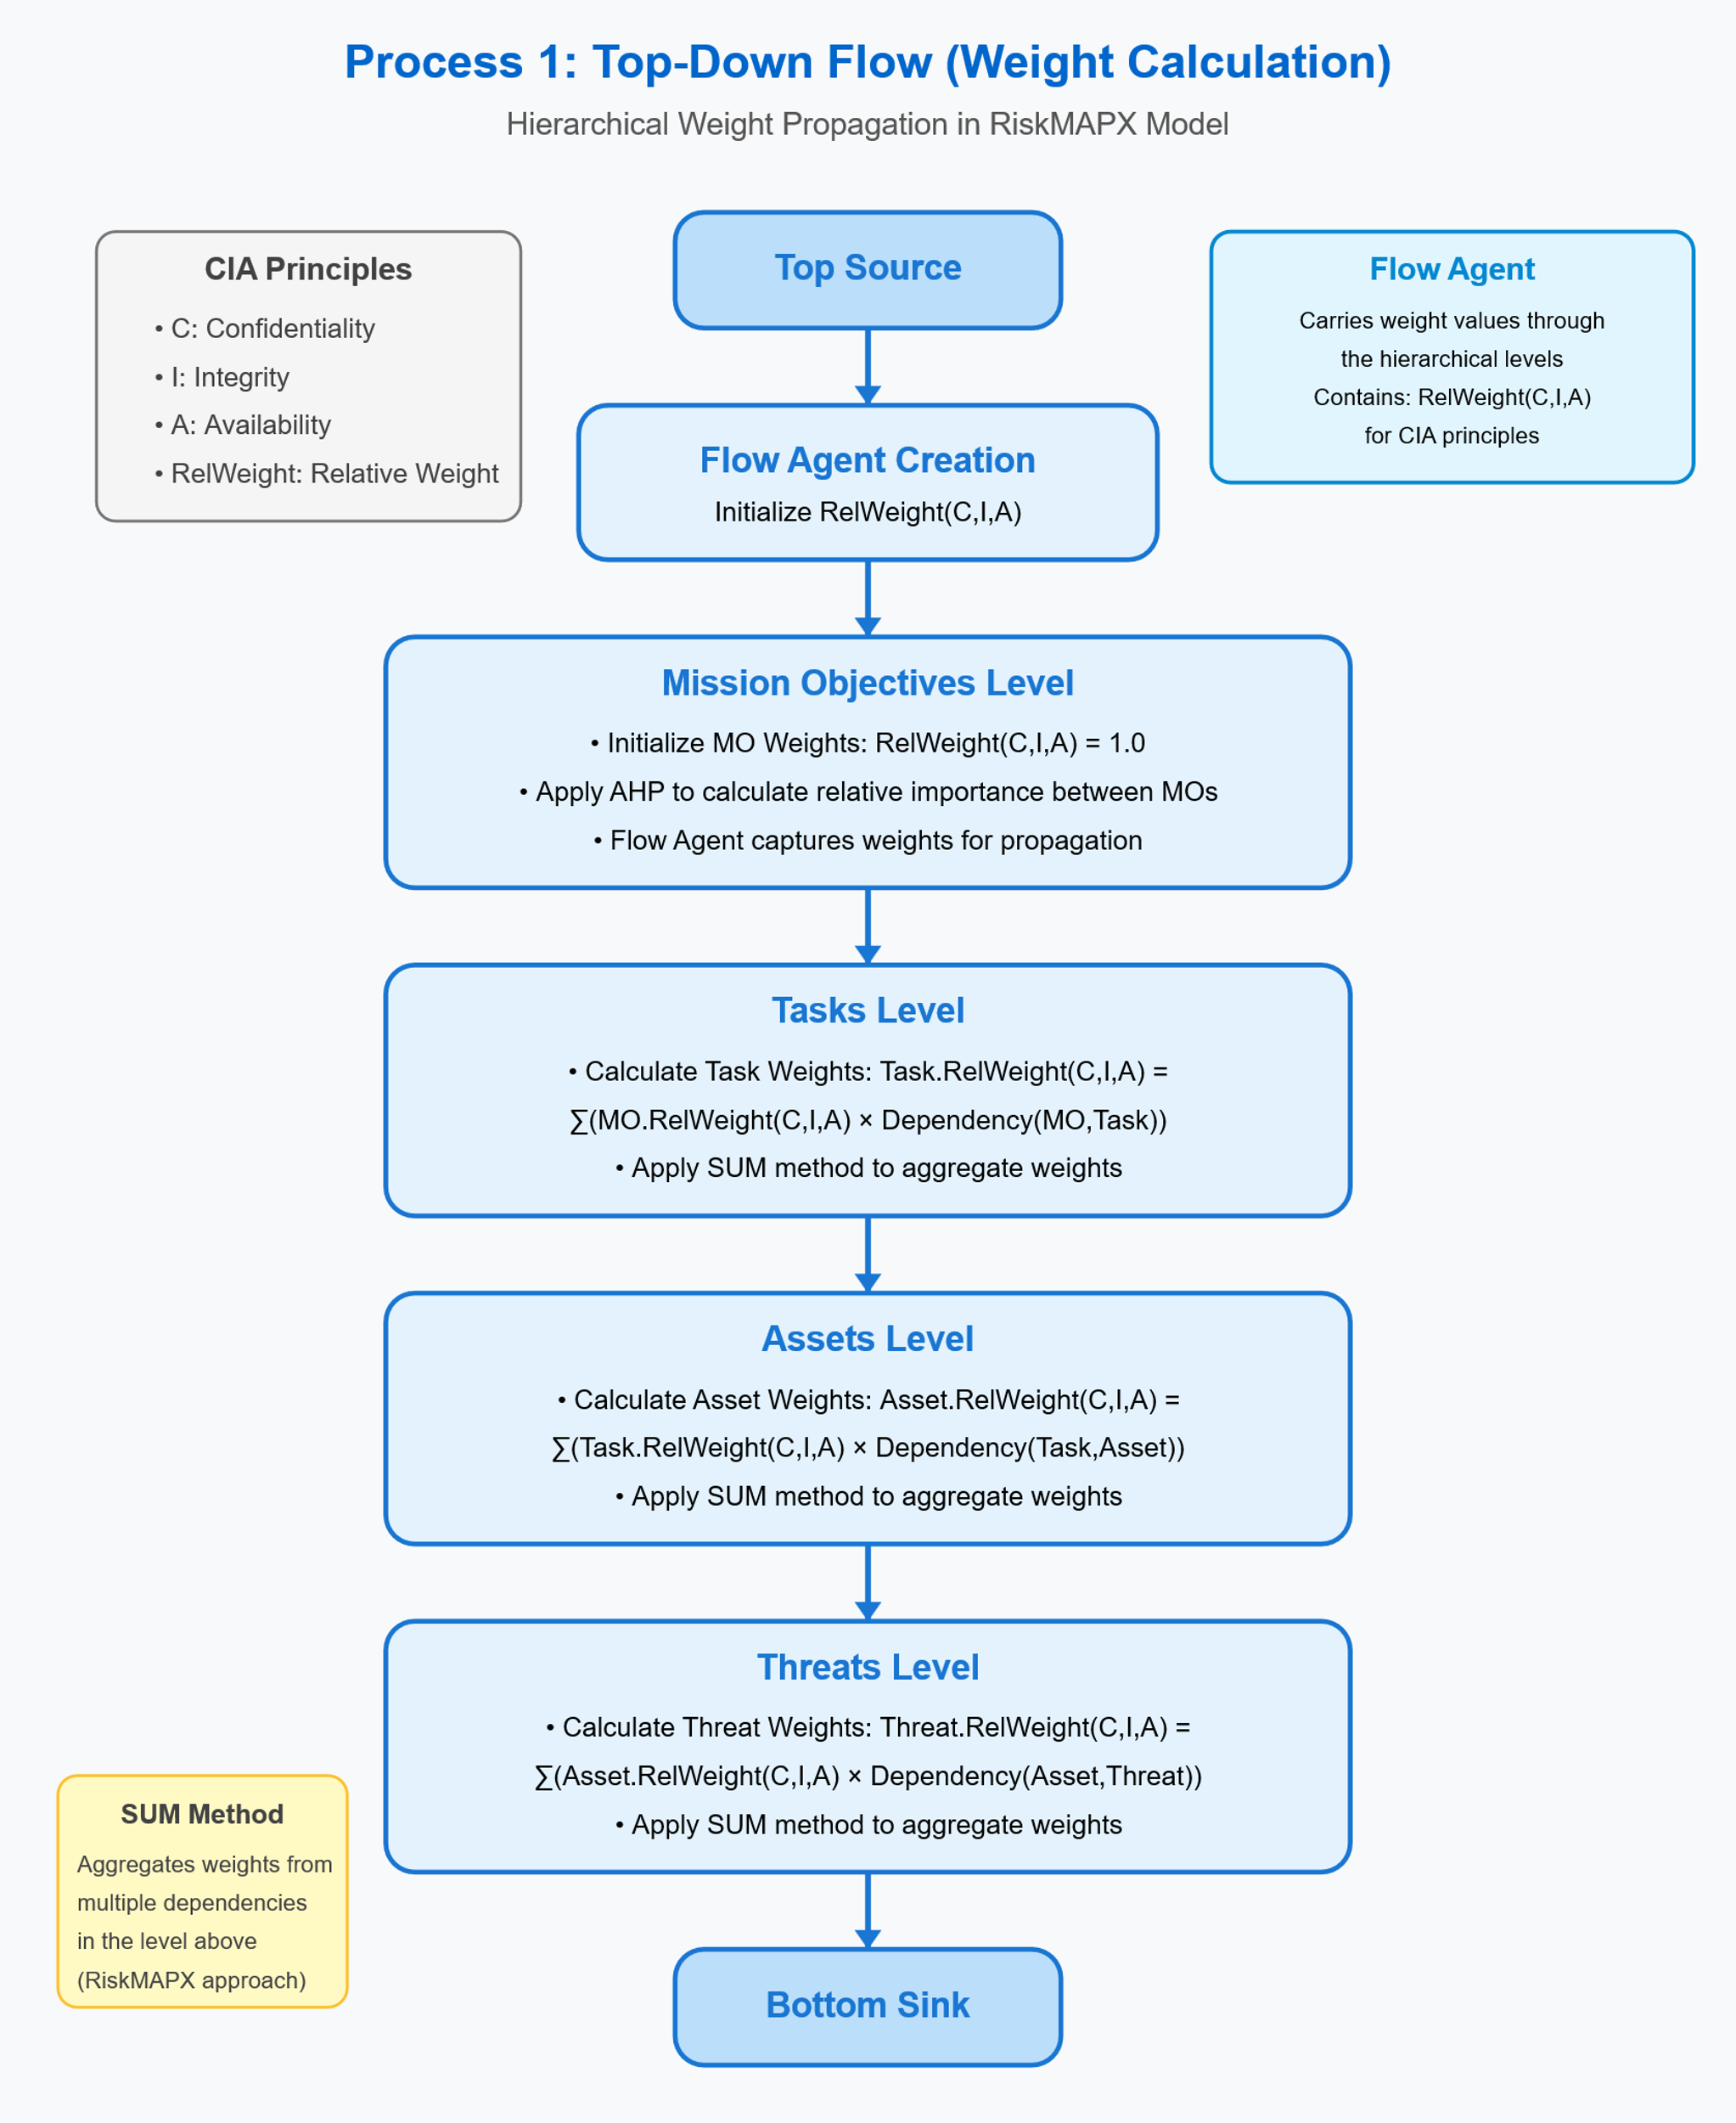
Figure 1. Top-Down Hierarchical Weight Propagation Workflow in the RiskMAPX Security Assessment Model
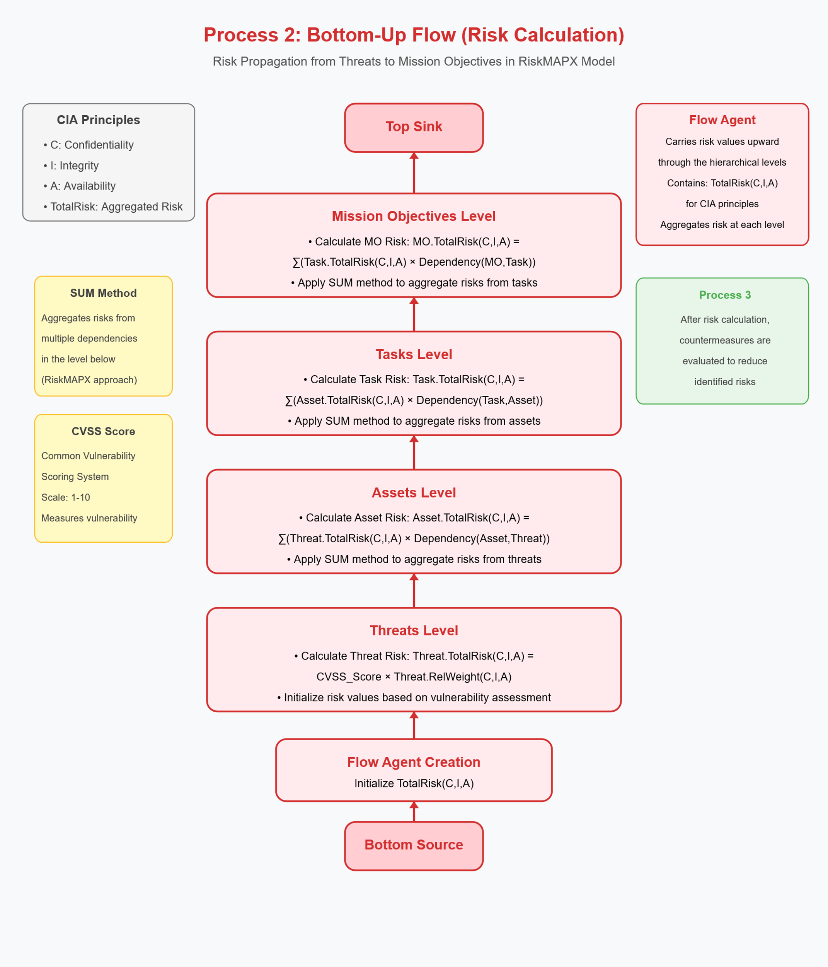
Figure 2. Bottom-Up Risk Aggregation Process in the RiskMAPX Security Assessment Model
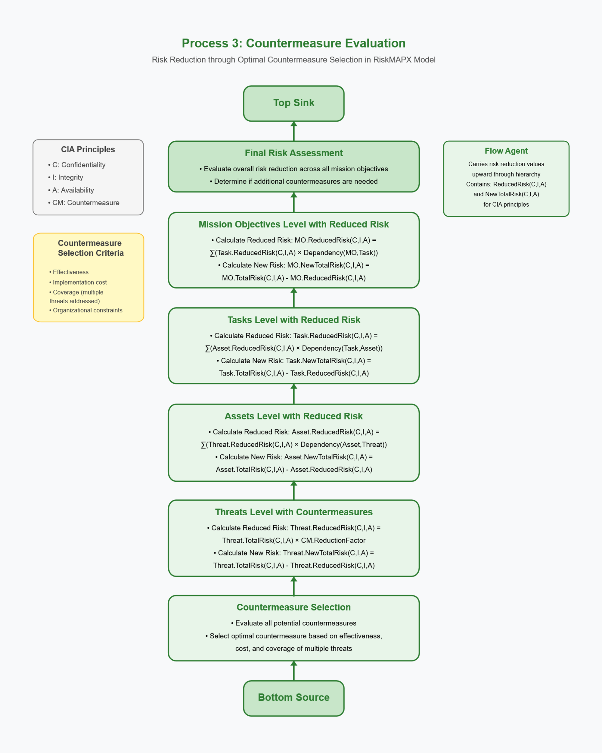
Figure 3. Countermeasure Evaluation and Risk Reduction Process in the RiskMAPX Framework
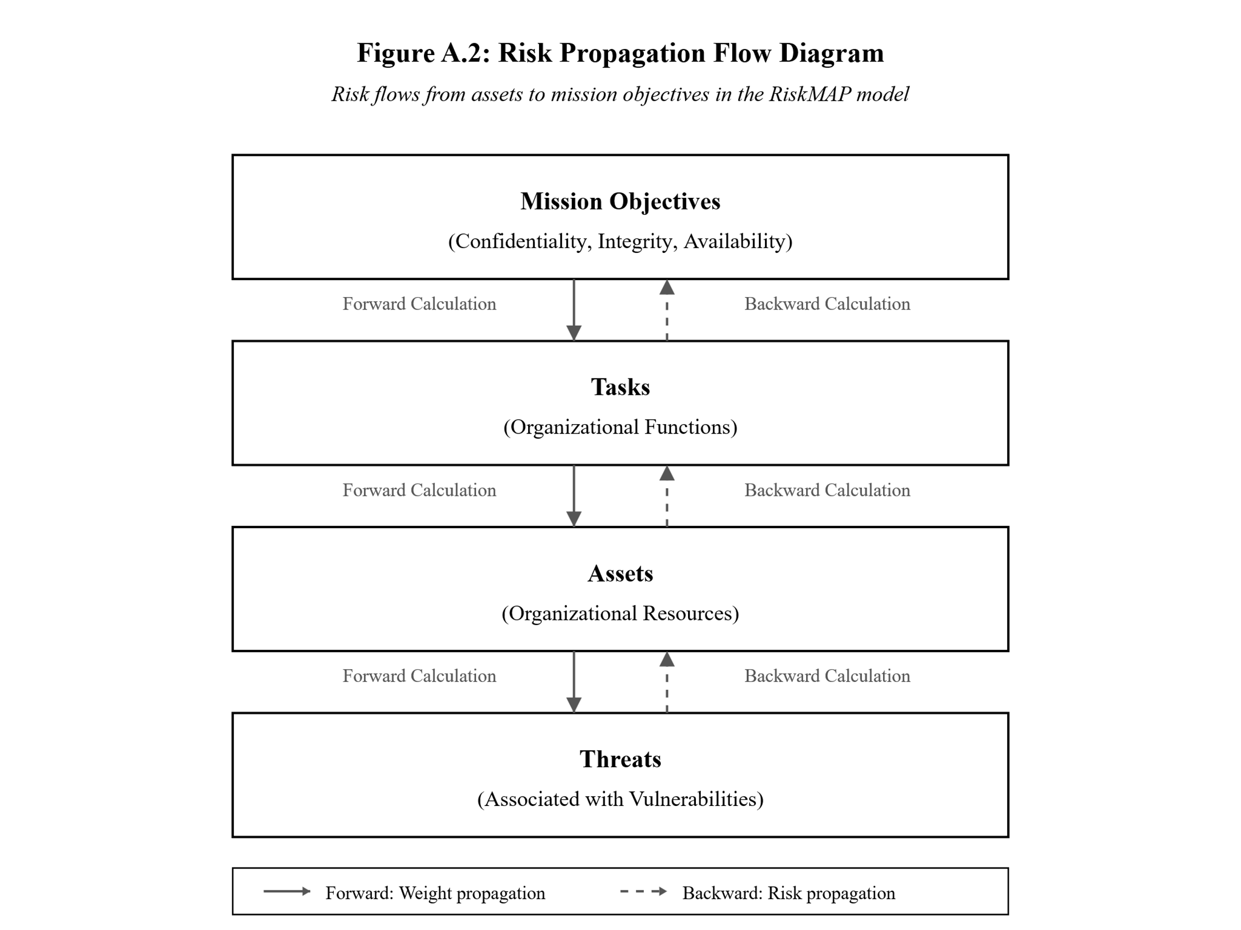
Figure 4. Bidirectional Risk and Weight Propagation in the RiskMAPX Framework

Table 4. Security Monitoring and Infrastructure Protection Task Definitions
ID | Name
Task1 | Maintenance and development of virtual infrastructure
Task2 | Backup of virtual infrastructure
Task3 | Monitoring of virtual infrastructure
Task4 | Review logs and events of virtual infrastructure.
Task5 | Implementation of cooling standards for data centers
Task6 | Implementation of cabling standards for data centers
Task7 | Implementation of backup power standards
Task8 | Implementation of fire suppression standards
Task9 | Creation and examination of network topology
Task10 | Creation of VLANs
Task11 | Securing communications between VLANs
Task12 | Monitoring and reviewing logs of switches and routers
Task13 | Creating backup files of configurations
Task14 | Establishing BGP communication
Task15 | Maintenance and configuration of edge firewalls
Task16 | Maintenance and configuration of edge routers
Task17 | Management and maintenance of the main Web Server2
Task18 | Management and maintenance of hosting servers
Task19 | Management and maintenance of DNS service
Task20 | Backup creation
Task21 | Reviewing and monitoring logs and events
Task22 | Management and maintenance of security equipment
Task23 | Security monitoring and log analysis using Splunk
Task24 | Monitoring system resources using Zabbix
Task25 | Periodic penetration testing
Task26 | Vulnerability scanning with Nessus
Task27 | Hardening and securing network switches
Task28 | Securing DNS services
Task29 | Securing web servers
Task30 | Updating frameworks and applying security patches

Table 5. Critical Network and Infrastructure Assets Identified for Protection Assessment
ID | Name
Asset1 | Edge router
Asset2 | External router
Asset3 | External firewall
Asset4 | Internal firewall
Asset5 | External DNS
Asset6 | Internal DNS
Asset7 | vCenter
Asset8 | vSwitch
Asset9 | Machine 1
Asset10 | Machine 2
Asset11 | Web Server 1
Asset12 | Web Server 2
Asset13 | Web Application Firewall

Table 6. Vulnerability Assessment Matrix with Associated CVSS Scores and Impact Ratings
ID | CVE Id | Name | CVSS Score C | CVSS Score I | CVSS Score A | Impact Score C | Impact Score I | Impact Score A | Likelihood Score
Vul1 | CVE-2021-40438 | Apache 2.4.x < 2.4.54 Multiple Vulnerabilities | 7.5 | 7.5 | 7.5 | 10 | 10 | 10 | 5
Vul2 | CVE-2022-1292 | OpenSSL 1.1.1 < 1.1.1o Vulnerability | 10 | 10 | 10 | 10 | 10 | 10 | 5
Vul3 | CVE-2015-4000 | SSL/TLS Diffie-Hellman Modulus <= 1024 Bits (Logjam) | 4.3 | 4.3 | 4.3 | 6 | 6 | 6 | 2
Vul4 | CVE-2004-2761 | SSL Certificate Signed Using Weak Hashing Algorithm | 5 | 5 | 5 | 10 | 3 | 3 | 2
Vul5 | CVE-2013-2566 | SSL RC4 Cipher Suites Supported (Bar Mitzvah) | 4.3 | 4.3 | 4.3 | 3 | 3 | 3 | 2
Vul6 | CVE-2016-2183 | SSL Medium Strength Cipher Suites Supported (SWEET32) | 5 | 5 | 5 | 6 | 6 | 6 | 2

Table 7. Threat Characterization and Vulnerability Association Matrix
ID | Name | Description | Related Vulnerability
Threat1 | Server-Side Request Forgery (SSRF) | Threat actors can exploit the CVE-2021-40438 vulnerability to trigger SSRF attacks by sending specially crafted requests to the Apache HTTP Server with the mod proxy module enabled | CVE-2021-40438
Threat2 | Remote Code Execution | An attacker could exploit the vulnerability to execute arbitrary commands on the system. | CVE-2022-1292
Threat3 | Unauthorized Access | An attacker could gain unauthorized access to sensitive information on the affected system. | CVE-2022-1292
Threat4 | Downgrade of DH parameter curves to export strength | The core attack is a downgrade of the DH parameters used during the initial TLS setup to an export strength of 512 bits. This allows attackers to break the DH key exchange with a 512-bit parameter set in near real-time | CVE-2015-4000
Threat5 | Spoofing Attacks | The vulnerability allows context-dependent attackers to conduct spoofing attacks by exploiting the MD5 algorithm in the signature algorithm of an X.509 certificate. | CVE-2004-2761
Threat6 | Plaintext-recovery attacks | Remote attackers can potentially recover specific plaintext data from an arbitrary ciphertext block in an SSH session. | CVE-2013-2566
Threat7 | Birthday Attack | The vulnerability allows remote attackers to attack a birthday against a long-duration encrypted session, potentially obtaining cleartext data. | CVE-2016-2183

Table 8. Countermeasure Analysis with Implementation Status, Cost, and Operational Impact
ID | Name | Has Been Deployed | Total Cost | Negative Impact on QoS
Countermeasure1 | Upgrade to the Latest Version of Apache | FALSE | 500 | 2
Countermeasure2 | Disable or Limit mod proxy Module | FALSE | 200 | 2
Countermeasure3 | Implement Web Application Firewalls (WAF) | TRUE | 2000 | 3
Countermeasure4 | Input Validation and Filtering | FALSE | 100 | 2
Countermeasure5 | Implement Network Segmentation | FALSE | 1 | 1
Countermeasure6 | Apply the latest fixes of OpenSSL | FALSE | 3000 | 10
Countermeasure7 | Upgrade to supported versions of OpenSSL | FALSE | 3000 | 10
Countermeasure8 | Implement strong access controls | FALSE | 3000 | 10
Countermeasure9 | Monitor network traffic | FALSE | 3000 | 10
Countermeasure10 | Educate users | FALSE | 3000 | 10
Countermeasure11 | Upgrade SSL client applications and libraries | FALSE | 1000 | 3
Countermeasure12 | Use of specific and static DH parameter sets | FALSE | 100 | 2
Countermeasure13 | Upgrade to a Secure Hash Algorithm | FALSE | 500 | 3
Countermeasure14 | Replace MD5 Certificates | FALSE | 2000 | 3
Countermeasure15 | Implement Certificate Authorities (CAs) Best Practices | FALSE | 2000 | 3
Countermeasure16 | Upgrade to a secure version of TLS and SSL | FALSE | 500 | 2
Countermeasure17 | Disable RC4 cipher suites | FALSE | 200 | 2
Countermeasure18 | Use strong encryption algorithms such as AES | FALSE | 1000 | 3
Countermeasure19 | Disable 3DES Cipher Suites | FALSE | 200 | 2

Table 9. Risk Reduction Effectiveness of Countermeasures Against Identified Threats Across CIA Triad Dimensions
CM ID | Threats ID | Risk Reduction C | Risk Reduction I | Risk Reduction A
Countermeasure1 | Threat1 | 0.8 | 0.7 | 0.9
Countermeasure2 | Threat1 | 0.6 | 0.5 | 0.8
Countermeasure3 | Threat1 | 0.9 | 0.8 | 0.7
Countermeasure4 | Threat1 | 0.7 | 0.6 | 0.5
Countermeasure5 | Threat1 | 0.8 | 0.9 | 0.7
Countermeasure5 | Threat2 | 0.7 | 0.8 | 0.9
Countermeasure6 | Threat2 | 0.6 | 0.7 | 0.8
Countermeasure7 | Threat2 | 0.9 | 0.6 | 0.7
Countermeasure8 | Threat2 | 0.8 | 0.7 | 0.6
Countermeasure9 | Threat2 | 0.7 | 0.9 | 0.8
Countermeasure10 | Threat2 | 0.9 | 0.8 | 0.7
Countermeasure5 | Threat3 | 0.9 | 0.9 | 0.9
Countermeasure6 | Threat3 | 0.1 | 0.1 | 0.1
Countermeasure7 | Threat3 | 0.1 | 0.1 | 0.1
Countermeasure8 | Threat3 | 0.1 | 0.1 | 0.1
Countermeasure9 | Threat3 | 0.1 | 0.1 | 0.1
Countermeasure10 | Threat3 | 0.1 | 0.1 | 0.1
Countermeasure11 | Threat4 | 0.9 | 0.6 | 0.7
Countermeasure12 | Threat4 | 0.8 | 0.7 | 0.6
Countermeasure13 | Threat5 | 0.7 | 0.9 | 0.8
Countermeasure14 | Threat5 | 0.6 | 0.8 | 0.9
Countermeasure15 | Threat5 | 0.8 | 0.7 | 0.6
Countermeasure16 | Threat6 | 0.7 | 0.6 | 0.8
Countermeasure17 | Threat6 | 0.9 | 0.8 | 0.7
Countermeasure18 | Threat6 | 0.8 | 0.7 | 0.9
Countermeasure19 | Threat7 | 0.6 | 0.9 | 0.8

Table 10. Mission-Critical Task Importance Ratings Across Confidentiality, Integrity, and Availability Security Attributes
Block Id | Importance C | Importance I | Importance A
MO1_T1 | 8 | 8 | 8
MO1_T2 | 4 | 4 | 4
MO1_T3 | 4 | 4 | 4
MO1_T4 | 4 | 4 | 4
MO1_T5 | 8 | 8 | 8
MO1_T6 | 8 | 8 | 8
MO1_T7 | 8 | 8 | 8
MO1_T8 | 4 | 4 | 4
MO1_T9 | 4 | 4 | 4
MO1_T10 | 4 | 4 | 4
MO1_T11 | 4 | 4 | 4
MO1_T12 | 4 | 4 | 4
MO1_T13 | 4 | 4 | 4
MO1_T14 | 8 | 8 | 8
MO1_T15 | 8 | 8 | 8
MO1_T16 | 8 | 8 | 8
MO2_T17 | 8 | 8 | 8
MO2_T18 | 8 | 8 | 8
MO2_T19 | 8 | 8 | 8
MO2_T20 | 4 | 4 | 4
MO2_T21 | 4 | 4 | 4
MO3_T22 | 8 | 8 | 8
MO3_T23 | 4 | 4 | 4
MO3_T24 | 4 | 4 | 4
MO3_T25 | 4 | 4 | 4
MO3_T26 | 4 | 4 | 4
MO3_T27 | 4 | 4 | 4
MO3_T28 | 4 | 4 | 4
MO3_T29 | 4 | 4 | 4
MO3_T30 | 4 | 4 | 4
T1_A7 | 8 | 8 | 8
T1_A8 | 8 | 8 | 8
T2_A7 | 4 | 4 | 4
T2_A8 | 4 | 4 | 4
T3_A7 | 4 | 4 | 4
T3_A8 | 4 | 4 | 4
T4_A7 | 4 | 4 | 4
T4_A8 | 4 | 4 | 4
T5_A1 | 8 | 8 | 8
T5_A2 | 8 | 8 | 8
T5_A3 | 8 | 8 | 8
T5_A4 | 8 | 8 | 8
T5_A9 | 8 | 8 | 8
T5_A10 | 8 | 8 | 8
T6_A1 | 8 | 8 | 8
T6_A2 | 8 | 8 | 8
T6_A3 | 8 | 8 | 8
T6_A4 | 8 | 8 | 8
T6_A9 | 8 | 8 | 8
T6_A10 | 8 | 8 | 8
T7_A1 | 8 | 8 | 8
T7_A2 | 8 | 8 | 8
T7_A3 | 8 | 8 | 8
T7_A4 | 8 | 8 | 8
T7_A9 | 8 | 8 | 8
T7_A10 | 8 | 8 | 8
T8_A1 | 4 | 4 | 4
T8_A2 | 4 | 4 | 4
T8_A3 | 4 | 4 | 4
T8_A4 | 4 | 4 | 4
T8_A9 | 4 | 4 | 4
T8_A10 | 4 | 4 | 4
T9_A1 | 4 | 4 | 4
T9_A2 | 4 | 4 | 4
T9_A3 | 4 | 4 | 4
T9_A4 | 4 | 4 | 4
T9_A5 | 4 | 4 | 4
T9_A6 | 4 | 4 | 4
T9_A7 | 4 | 4 | 4
T9_A8 | 4 | 4 | 4
T9_A9 | 4 | 4 | 4
T9_A10 | 4 | 4 | 4
T9_A11 | 4 | 4 | 4
T9_A12 | 4 | 4 | 4
T9_A13 | 4 | 4 | 4
T10_A1 | 4 | 4 | 4
T10_A2 | 4 | 4 | 4
T10_A4 | 4 | 4 | 4
T10_A7 | 4 | 4 | 4
T10_A8 | 4 | 4 | 4
T11_A1 | 4 | 4 | 4
T11_A2 | 4 | 4 | 4
T11_A4 | 4 | 4 | 4
T11_A7 | 4 | 4 | 4
T11_A8 | 4 | 4 | 4
T12_A1 | 4 | 4 | 4
T12_A2 | 4 | 4 | 4
T12_A4 | 4 | 4 | 4
T12_A7 | 4 | 4 | 4
T12_A8 | 4 | 4 | 4
T13_A1 | 4 | 4 | 4
T13_A2 | 4 | 4 | 4
T13_A4 | 4 | 4 | 4
T13_A7 | 4 | 4 | 4
T13_A8 | 4 | 4 | 4
T14_A1 | 8 | 8 | 8
T14_A2 | 8 | 8 | 8
T14_A4 | 8 | 8 | 8
T14_A8 | 8 | 8 | 8
T15_A3 | 8 | 8 | 8
T16_A1 | 8 | 8 | 8
T17_A10 | 8 | 8 | 8
T17_A12 | 8 | 8 | 8
T18_A9 | 8 | 8 | 8
T18_A11 | 8 | 8 | 8
T19_A5 | 8 | 8 | 8
T19_A6 | 8 | 8 | 8
T19_A7 | 8 | 8 | 8
T19_A8 | 8 | 8 | 8
T20_A1 | 4 | 4 | 4
T20_A2 | 4 | 4 | 4
T20_A3 | 4 | 4 | 4
T20_A4 | 4 | 4 | 4
T20_A5 | 4 | 4 | 4
T20_A6 | 4 | 4 | 4
T20_A7 | 4 | 4 | 4
T20_A8 | 4 | 4 | 4
T20_A9 | 4 | 4 | 4
T20_A10 | 4 | 4 | 4
T20_A11 | 4 | 4 | 4
T20_A12 | 4 | 4 | 4
T20_A13 | 4 | 4 | 4
T21_A1 | 4 | 4 | 4
T21_A2 | 4 | 4 | 4
T21_A3 | 4 | 4 | 4
T21_A4 | 4 | 4 | 4
T21_A5 | 4 | 4 | 4
T21_A6 | 4 | 4 | 4
T21_A7 | 4 | 4 | 4
T21_A8 | 4 | 4 | 4
T21_A9 | 4 | 4 | 4
T21_A10 | 4 | 4 | 4
T21_A11 | 4 | 4 | 4
T21_A12 | 4 | 4 | 4
T21_A13 | 4 | 4 | 4
T22_A3 | 8 | 8 | 8
T22_A4 | 8 | 8 | 8
T22_A13 | 8 | 8 | 8
T23_A4 | 4 | 4 | 4
T23_A13 | 4 | 4 | 4
T24_A1 | 4 | 4 | 4
T24_A2 | 4 | 4 | 4
T24_A3 | 4 | 4 | 4
T24_A4 | 4 | 4 | 4
T24_A5 | 4 | 4 | 4
T24_A6 | 4 | 4 | 4
T24_A7 | 4 | 4 | 4
T24_A8 | 4 | 4 | 4
T24_A9 | 4 | 4 | 4
T24_A10 | 4 | 4 | 4
T24_A11 | 4 | 4 | 4
T24_A12 | 4 | 4 | 4
T24_A13 | 4 | 4 | 4
T25_A1 | 4 | 4 | 4
T25_A2 | 4 | 4 | 4
T25_A3 | 4 | 4 | 4
T25_A4 | 4 | 4 | 4
T25_A5 | 4 | 4 | 4
T25_A6 | 4 | 4 | 4
T25_A7 | 4 | 4 | 4
T25_A8 | 4 | 4 | 4
T25_A9 | 4 | 4 | 4
T25_A10 | 4 | 4 | 4
T25_A11 | 4 | 4 | 4
T25_A12 | 4 | 4 | 4
T25_A13 | 4 | 4 | 4
T26_A1 | 4 | 4 | 4
T26_A2 | 4 | 4 | 4
T26_A3 | 4 | 4 | 4
T26_A4 | 4 | 4 | 4
T26_A5 | 4 | 4 | 4
T26_A6 | 4 | 4 | 4
T26_A7 | 4 | 4 | 4
T26_A8 | 4 | 4 | 4
T26_A9 | 4 | 4 | 4
T26_A10 | 4 | 4 | 4
T26_A11 | 4 | 4 | 4
T26_A12 | 4 | 4 | 4
T26_A13 | 4 | 4 | 4
T27_A1 | 4 | 4 | 4
T27_A2 | 4 | 4 | 4
T27_A4 | 4 | 4 | 4
T28_A5 | 4 | 4 | 4
T28_A6 | 4 | 4 | 4
T29_A11 | 4 | 4 | 4
T29_A12 | 4 | 4 | 4
T30_A1 | 4 | 4 | 4
T30_A2 | 4 | 4 | 4
T30_A3 | 4 | 4 | 4
T30_A4 | 4 | 4 | 4
T30_A5 | 4 | 4 | 4
T30_A6 | 4 | 4 | 4
T30_A7 | 4 | 4 | 4
T30_A8 | 4 | 4 | 4
T30_A9 | 4 | 4 | 4
T30_A10 | 4 | 4 | 4
T30_A11 | 4 | 4 | 4
T30_A12 | 4 | 4 | 4
T30_A13 | 4 | 4 | 4
A1_Th4 | 8 | 8 | 8
A1_Th5 | 6 | 6 | 6
A1_Th6 | 5 | 5 | 5
A1_Th7 | 7 | 7 | 7
A2_Th4 | 7 | 7 | 7
A2_Th5 | 6 | 6 | 6
A2_Th6 | 4 | 4 | 4
A2_Th7 | 5 | 5 | 5
A3_Th4 | 9 | 9 | 9
A3_Th5 | 8 | 8 | 8
A3_Th6 | 7 | 7 | 7
A3_Th7 | 6 | 6 | 6
A4_Th4 | 9 | 9 | 9
A4_Th5 | 7 | 7 | 7
A4_Th6 | 6 | 6 | 6
A4_Th7 | 8 | 8 | 8
A5_Th1 | 7 | 7 | 7
A5_Th2 | 9 | 9 | 9
A6_Th1 | 6 | 6 | 6
A6_Th2 | 8 | 8 | 8
A7_Th2 | 9 | 9 | 9
A7_Th4 | 9 | 9 | 9
A7_Th5 | 8 | 8 | 8
A7_Th6 | 7 | 7 | 7
A7_Th7 | 7 | 7 | 7
A8_Th1 | 6 | 6 | 6
A8_Th2 | 8 | 8 | 8
A9_Th1 | 7 | 7 | 7
A9_Th2 | 9 | 9 | 9
A9_Th3 | 6 | 6 | 6
A9_Th4 | 8 | 8 | 8
A9_Th5 | 7 | 7 | 7
A9_Th6 | 6 | 6 | 6
A9_Th7 | 7 | 7 | 7
A10_Th1 | 5 | 5 | 5
A10_Th2 | 8 | 8 | 8
A10_Th3 | 6 | 6 | 6
A10_Th4 | 7 | 7 | 7
A10_Th5 | 6 | 6 | 6
A10_Th6 | 5 | 5 | 5
A10_Th7 | 6 | 6 | 6
A11_Th1 | 6 | 6 | 6
A11_Th2 | 9 | 9 | 9
A11_Th3 | 7 | 7 | 7
A11_Th4 | 8 | 8 | 8
A11_Th5 | 7 | 7 | 7
A11_Th6 | 6 | 6 | 6
A11_Th7 | 6 | 6 | 6
A12_Th1 | 5 | 5 | 5
A12_Th2 | 8 | 8 | 8
A12_Th3 | 6 | 6 | 6
A12_Th4 | 7 | 7 | 7
A12_Th5 | 6 | 6 | 6
A12_Th6 | 5 | 5 | 5
A12_Th7 | 6 | 6 | 6
A13_Th4 | 7 | 7 | 7
A13_Th5 | 8 | 8 | 8
A13_Th6 | 6 | 6 | 6
A13_Th7 | 7 | 7 | 7

Table 11. Decision Parameters for Security Implementation
Value | Parameter ID | Title of Decision Parameter
5,000$ | MaxBudget | Maximum Budget
0.1 | W_RR_C | Weight for Risk Reduction in Confidentiality
0.4 | W_RR_I | Weight for Risk Reduction in Integrity
0.5 | W_RR_A | Weight for Risk Reduction in Availability
0.4 | W_RR | Weight for Risk Reduction
0.2 | W_DC | Weight for Deployment Cost
0.3 | W_QS | Weight for Quality of Service
0.1 | W_TRRC | Weight for Total Risk Reduction in Confidentiality
0.4 | W_TRRCC | Weight for Total Risk Reduction Cost in Confidentiality
0.3 | W_TRRCI | Weight for Total Risk Reduction Cost in Integrity
0.3 | W_TRRCA | Weight for Total Risk Reduction Cost in Availability
0.1 | W_TPSC | Weight for Total Protection Score in Confidentiality
0.4 | W_TPSI | Weight for Total Protection Score in Integrity
0.5 | W_TPSA | Weight for Total Protection Score in Availability

Table 12. Risk Reduction Percentages by Mission Objective
Mission Objective | Risk Reduction in Availability (%) | Risk Reduction in Integrity (%) | Risk Reduction in Confidentiality (%)
Service Deployment | 97% | 97% | 97%
Service Enhancement | 85% | 85% | 82%
Security Assurance | 89% | 89% | 87%

Table 13. Countermeasure Effectiveness and Risk Impact Analysis
Countermeasure |  | TotalRiskC | TotalRiskI | TotalRiskA | NewTotalRiskC | NewTotalRiskI | NewTotalRiskA | Cost ($)
Cm5 | Threat3 | 10 | 10 | 10 | 3 | 4 | 4 | 3000
 | Service Deployment | 8.063×10⁸ | 6.783×10⁸ | 6.783×10⁸ | 2.203×10⁷ | 1.431×10⁷ | 1.431×10⁷
 | Service Enhancement | 2.673×10⁸ | 2.468×10⁸ | 2.468×10⁸ | 4.292×10⁷ | 2.830×10⁷ | 2.830×10⁷
 | Security Assurance | 2.401×10⁹ | 2.134×10⁹ | 2.134×10⁹ | 2.776×10⁸ | 1.831×10⁸ | 1.831×10⁸
Cm6 | Threat3 | 10 | 10 | 10 | 2 | 1 | 1 | 100
 | Service Deployment | 8.063×10⁸ | 6.783×10⁸ | 6.783×10⁸ | 2.459×10⁷ | 1.84×10⁷ | 1.84×10⁷
 | Service Enhancement | 2.673×10⁸ | 2.468×10⁸ | 2.468×10⁸ | 4.821×10⁷ | 3.598×10⁷ | 3.598×10⁷
 | Security Assurance | 2.401×10⁹ | 2.134×10⁹ | 2.134×10⁹ | 3.14×10⁸ | 2.344×10⁸ | 2.344×10⁸
Cm7 | Threat3 | 10 | 10 | 10 | 4 | 3 | 3 | 500
 | Service Deployment | 8.063×10⁸ | 6.783×10⁸ | 6.783×10⁸ | 6.494×10⁶ | 2.469×10⁷ | 2.469×10⁷
 | Service Enhancement | 2.673×10⁸ | 2.468×10⁸ | 2.468×10⁸ | 1.332×10⁷ | 4.857×10⁷ | 4.857×10⁷
 | Security Assurance | 2.401×10⁹ | 2.134×10⁹ | 2.134×10⁹ | 8.625×10⁷ | 3.162×10⁸ | 3.162×10⁸
Cm8 | Threat3 | 10 | 10 | 10 | 1 | 2 | 2 | 1000
 | Service Deployment | 8.063×10⁸ | 6.783×10⁸ | 6.783×10⁸ | 1.23×10⁷ | 1.849×10⁷ | 8.063×10⁸
 | Service Enhancement | 2.673×10⁸ | 2.468×10⁸ | 2.468×10⁸ | 2.411×10⁷ | 3.634×10⁷ | 2.673×10⁸
 | Security Assurance | 2.401×10⁹ | 2.134×10⁹ | 2.134×10⁹ | 1.57×10⁸ | 2.366×10⁸ | 2.401×10⁹
Cm9 | Threat3 | 10 | 10 | 10 | 3 | 4 | 4 | 1000
 | Service Deployment | 8.063×10⁸ | 6.783×10⁸ | 6.783×10⁸ | 1.859×10⁷ | 6.494×10⁶ | 6.494×10⁶
 | Service Enhancement | 2.673×10⁸ | 2.468×10⁸ | 2.468×10⁸ | 3.67×10⁷ | 1.332×10⁷ | 1.332×10⁷
 | Security Assurance | 2.401×10⁹ | 2.134×10⁹ | 2.134×10⁹ | 2.388×10⁸ | 8.625×10⁷ | 8.625×10⁷
Cm10 | Threat3 | 10 | 10 | 10 | 2 | 3 | 3 | 500
 | Service Deployment | 8.063×10⁸ | 6.783×10⁸ | 6.783×10⁸ | 6.297×10⁶ | 1.249×10⁷ | 1.249×10⁷
 | Service Enhancement | 2.673×10⁸ | 2.468×10⁸ | 2.468×10⁸ | 1.26×10⁷ | 2.483×10⁷ | 2.483×10⁷
 | Security Assurance | 2.401×10⁹ | 2.134×10⁹ | 2.134×10⁹ | 8.182×10⁷ | 1.614×10⁸ | 1.614×10⁸

Table 14. Countermeasure Cost-Benefit Analysis
Countermeasure | Cost ($) | Risk Reduction |  |  | Avg Risk Reduction | Benefit/Cost Ratio
 |  | Confidentiality | Integrity | Availability
Cm5 | 3,000 | 89% | 90% | 90% | 89.7% | 0.030
Cm6 | 100 | 87% | 87% | 87% | 87.0% | 0.870
Cm7 | 500 | 86% | 85% | 85% | 85.3% | 0.171
Cm8 | 1,000 | 88% | 87% | 87% | 87.3% | 0.087
Cm9 | 1,000 | 88% | 89% | 89% | 88.7% | 0.089
Cm10 | 500 | 87% | 87% | 87% | 87.0% | 0.174

